MiSACWIS Project

CF02 – Identify On-Call Staff Screen Specification

Version 1.2

March 7, 2012
Prepared for:


120 N. Washington Square
SACWIS Project, 3rd Floor
Lansing, MI 48933

Prepared by:

Revision Log
Version | Date | A/D/C (Add, Delete, Change) | Author | Document Section # | Description
0.1 | 07/19/2011 |  | Matthew McElver |  | Initial version
0.2 | 12/06/2011 | C | S Kulkarni | 3.1.2 | Updated field grids
0.3 | 12/09/2011 | C | S Kulkarni | 3.1.2,3.1.3,3.2.2,3.2.3 | Updated the sections
0.4 | 12/12/2011 | C | S Kulkarni | 3.2.3 | Updated field grid
1.0 | 12/13/2011 | C | Mark Van Hoose | All | Iteration 9 Approved
1.1 | 01/04/2012 | C | B. Palmer-Scott | 1 | Updated purpose and scope based on edited use case description
1.2 | 03/07/2012 | C | Mark Van Hoose | 3.1.5, 3.2.3, 3.2.5 | Change Control 6026

Table of Contents
1 Introduction 5
1.1 Purpose 5
1.2 Scope 5
2 Use Case Details 6
2.1.1 Action Buttons/Hyperlinks 6
2.1.2 Business Rules 7
2.1.3 Security Requirements 7
2.1.4 Screen Navigation 7
2.1.5 Tab Order 7
2.1.6 Pre-Conditions 7
2.1.7 Ticklers 8
2.1.8 Notifications 8
2.1.9 Calendar 8
2.1.10 Reports 8
2.1.11 Notes and Assumptions 8
3 Screen Details 9
3.1 S01 – On Call Employee Screen 9
3.1.1 As Is – Screen Mock Up 9
3.1.2 To Be – Screen Mock Up 9
3.1.3 Screen Fields 10
3.1.4 Action Buttons/Hyperlinks 13
3.1.5 Business Rules 13
3.1.6 Screen Navigation 14
3.1.7 Pre-Conditions 14
3.1.8 Reference Values 14
3.2 S02 – On Call Detail Screen 15
3.2.1 As Is – Screen Mock Up 15
3.2.2 To Be – Screen Mock Up 15
3.2.3 Screen Fields 16
3.2.4 Action Buttons/Hyperlinks 19
3.2.5 Business Rules 19
3.2.6 Screen Navigation 19
3.2.7 Pre-Conditions 19
3.2.8 Reference Values 19

List of Figures
Figure 1 – On Call Employee Screen – Existing Screen Mock Up 9
Figure 2 – On Call Employee Screen – Updated Screen Mock Up 9
Figure 3 – Screen – On Call Detail Screen – Existing Screen Mock Up 15
Figure 4 – Screen – On Call detail – Updated Screen Mock Up 15

- Introduction

Purpose
The CF02 - Identify On-Call Staff use case allows users to create and maintain a schedule of on-call employees..

Scope
On-call employees are staff members who receive referrals of new investigations or who work on ongoing/active cases or investigations in emergency situations. When setting up a new on-call record, MiSACWIS requires that users search to verify that an on-call record does not exist. If one does not exist, users can add a new on-call record. MiSACWIS next requires that users specify the employee for the on-call record by doing an employee search. MiSACWIS automatically fills in the organization, on-call schedule type, and contact numbers for the employee, based on the search by the user. The primary and secondary contacts are the phone numbers stored on the person record of the selected employee. Next, users must specify a begin time, an end time, and the counties that the on-call schedule covers. If the employee is a back up rather than the primary on-call person for the specified county or counties, this is indicated on the page.

- Use Case Details

    - Action Buttons/Hyperlinks
Status (Keep/Add/Modify/Delete) | Label | Type | On Click Action/Navigation
 | N/A

    - Business Rules
No. | Status (Keep/Add/Modify/Delete) | Business Rule Description | Modified Business Rule Description | Execution Event (field tab out/save etc) | Error Msg Code  To be completed by Development Team
 |  | N/A
    - Security Requirements
No. | Status (Keep/Add/Modify/Delete) | Security Requirement
1 | Keep | Create  Staff Administrator has the rights to Create.
2 | Keep | Read  Worker has the rights to Read.
3 | Keep | Update  Staff Administrator has the rights to Update.
4 | Keep | Delete  Staff Administrator has the rights to Delete.
    - Screen Navigation

No. | Status (Keep/Add/Modify/Delete) | To Screen Navigation Path
1 | Modify | Administration>Staff tab> Intake/On-Call Employee hyperlink
    - Tab Order
No. | Status (Keep/Add/Modify/Delete) | Screen name
N/A |  | N/A

    - Pre-Conditions
No. | Status (Keep/Add/Modify/Delete) | Pre-Condition
1 | Keep | Organization/Employee records must exist in MiSACWIS .
    - Ticklers
Status (Keep/Add/Modify/Delete) | Tickler Name | Trigger Action | Tickler Generation Business Rule & Description | Tickler Removal Business Rule | Tickler Text
Status (Keep/Add/Modify/Delete) | Tickler Role
 | N/A
    - Notifications
Status (Keep/Add/Modify/Delete) | Notification Name | Trigger Action | Message Business Rule & Description | Message Text
Status (Keep/Add/Modify/Delete) | Notification Role | Trigger Action | Message Business Rule & Description | Message Text
 | N/A
    - Calendar
Status (Keep/Add/Modify/Delete) | Calendar Name | Trigger Action | Calendar Event Generation Business Rule & Description | Calendar Event Date and Time Business Rule | Calendar Event Text
Status (Keep/Add/Modify/Delete) | Calendar Role
 | N/A
    - Reports
N/A

Notes and Assumptions
N/A

- Screen Details

S01 – On Call Employee Screen

As Is – Screen Mock Up
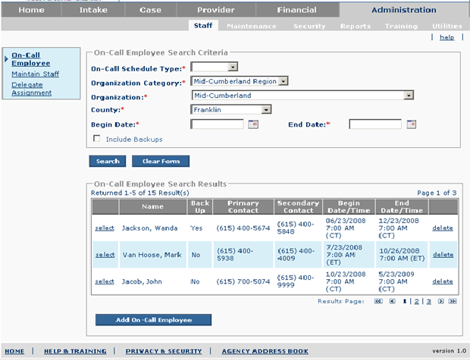
Figure 1 – On Call Employee Screen – Existing Screen Mock Up

To Be – Screen Mock Up
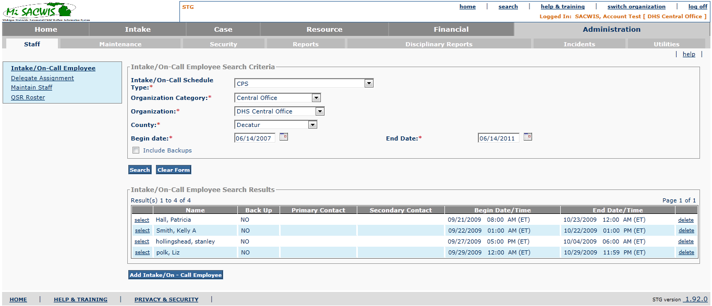
Figure 2 – Intake/On Call Employee Screen – Updated Screen Mock Up

Screen Fields
Status (Keep/Add/Modify/Delete) | As Is Class.Attribute Name | To Be  Class.Attribute Name | As Is Display Name | To Be Display Name | To Be Type | To Be Align | To Be Size | To Be Read Only | To Be Calculation | To Be Edit Mask | To Be  UI Validation
Modify | N/A | N/A | On-Call Employee Search Criteria | Intake/On-Call Employee Search Criteria | Section Header | L | N/A | T
Modify | OnCallStaff.scheduleType | OnCallStaff.scheduleType | On-Call Schedule Type | Intake/On-Call Schedule Type | Drop Down List | L | 100 | F | Domain Code: OnCallType |  | Required
Keep | Agency.agencyCategoryCode | Agency.agencyCategoryCode | Organization Category | Organization Category | Drop Down List | L | 100 | F | Domain Code: AgencyCategory |  | Required  Defaults to logged in user’s Organization Category.
Keep | Agency.agencyId | Agency.agencyId | Organization | Organization | Drop Down List | L | 100 | F | See BR 3.1.5.6 |  | Required  List of Organizations based on selection in Organization Category  Defaults to logged in user’s Organization.
Keep | AgencyCounty.countyCode | AgencyCounty.countyCode | County | County | Drop Down List | L | 100 | F | Domain Code: County |  | Required  List of County(ies) based on selection in Organization
Keep | OnCallStaff.StartDate | OnCallStaff.StartDate | Begin date | Begin date | Date Field | L | 10 | F |  | MM/DD/YYYY | Required Field  Default to today’s date
Keep | OnCallStaff.EndDate | OnCallStaff.EndDate | End Date | End Date | Date Field | L | 10 | F |  | MM/DD/YYYY | Required Field  Default to today’s date
Keep | OnCallStaff.IsBackupFlag | OnCallStaff.IsBackupFlag | Include Backups | Include Backups | Check box | L | N/A | F |  |  | Indicates if Backup Intake/On-call employees should be included in the search.
Modify | N/A | N/A | On-Call Employee Search Results | Intake/On-Call Employee Search Results | Section Header | L | N/A | T
Keep | Person.lastName + Person.firstName + Person.middleName | Person.lastName + + Person.suffixCode + Person.firstName + Person.middleName | Name | Name | Display Text | L | 100 | T |  | Last Name, Suffix Code, First Name  Middle Name0
Keep | OnCallStaff.IsBackupFlag | OnCallStaff.IsBackupFlag | Back Up | Back Up | Display Text | C | 22 | T | Displays ‘Yes’ if flag is true otherwise ‘No’
Keep | PartyContactMedium.PartyContact | PartyContactMedium.PartyContact | Primary Contact | Primary Contact | Display Text | L | 130 | T |  |  | Derived from the contact record for the selected employee where Contact Type = ‘Primary On-Call Contact’ and the Primary flag is set to true.
Keep | PartyContactMedium.PartyContact | PartyContactMedium.PartyContact | Secondary Contact | Secondary Contact | Display Text | L | 130 | T |  |  | Derived from the contact record for the selected employee where Contact Type = ‘Secondary On-Call Contact’ and the Primary flag is set to true.
Keep | OnCallStaff.StartDate | OnCallStaff.StartDate | Begin Date/Time | Begin Date/Time | Display Text | L | 30 | T |  | MM/DD/YYYY hh:mm (TZ)
Keep | OnCallStaff.EndDate | OnCallStaff.EndDate | End Date/Time | End Date/Time | Display Text | L | 30 | T |  | MM/DD/YYYY hh:mm (TZ)

Action Buttons/Hyperlinks
Status (Keep/Add/Modify/Delete) | Label | Type | On Click Action/Navigation
Keep | Search | Button | Returns rows that match the filter criteria
Keep | Clear Form | Button | Returns search criteria back to default values.
Keep | Select | Hyperlink | Go to on-call detail page – with pre-populated fields relative to the selected row.
Keep | Delete | Hyperlink | Deletes Intake/On-call Employee record from the database.
Modify | Add Intake/ On-Call Employee | Button | Launches CF16 Find an Employee with the following data passed to CF16: Organization Category, and Organization.

Business Rules
No. | Status (Keep/Add/Modify/Delete) | Business Rule Description | Modified Business Rule Description | Execution Event (field tab out/save etc) | Error Msg Code  To be completed by Development Team
1 | Keep | Only active employees can be designated for intake/on-call duties. Active employees are those who have not been terminated and are not on-leave and their access has not been suspended. |  | ‘Add Intake/On-call Employee’ button. Pre-condition sent to CF16 – Find an Employee Use Case that ‘include inactive’ field should not be checked and not available.
2 | Delete | When adding a new On-call employee the employee must have a ‘New Employee Certification’. |  | ‘Add On-call Employee’ Button. Pre-condition sent to CF16 – Find an Employee Use Case that License value should be = ‘New Employee Certification’.
3 | Keep | The End Date can never be before the Begin Date |  | Search Button
4 | Keep | The list of Intake/On-Call Employees should be sorted in order of Begin Date/Time in ascending order. If two On-call employees have the same Begin Date/Time next sort by ‘Back Up’ with ‘No’ above any ‘Yes’ values and then finally by alphabetical order. |  | Search Button
5 | Keep | Only Staff Administrators can add, modify, or delete on-call employees for their Organization. |  | ‘Select’ hyperlink changes to view only on the On-Call Detail Screen.  ‘Add Intake/On-Call Employee’ Button and ‘delete’ hyperlink disappear when logged in user’s Organization Category and Organization differs from selected Organization Category and Organization.
6 | Add | Organization drop down field is derived from the active organization values stored in the agency table that match the user selected Organization Category in alphabetical order.

Screen Navigation
No. | Status (Keep/Add/Modify/Delete) | To Screen Navigation Path
1 | Modify | This screen is accessed by clicking on the Intake/On-Call Employee hyperlink under the Administration>Staff tab.

Pre-Conditions
No. | Status (Keep/Add/Modify/Delete) | Pre-Condition
 | N/A | N/A

    - Reference Values
No. | Status (Keep/Add/Modify/Delete) | To Be Class Attribute | Domain Code | Short Desc | Ref Data Code
1 | Modify | OnCallStaff.scheduleType | OnCallType | CPS Supervisors - Regular Business Hours | CPSSUPERVISORBUSINESSHOURS
 |  |  |  | MIC Supervisors - Regular Business Hours | MICSUPERVISORBUSINESSHOURS
 |  |  |  | On-Call CPS Workers - After Hours | ONCALLCPWORHERAFTERHOURS
2 | Modify | Agency.agencyCategoryCode | AgencyCategory | Central Intake | CENTRALINTAKEORG
 |  |  |  | Central Office | CENTRALOFFICEORG
 |  |  |  | DHS Residential | DHSRESIDENTIAL
 |  |  |  | DHS County Office | DHSCOUNTY OFFICE
 |  |  |  | Other | OTHER
 |  |  |  | Other State Agency | OTHERSTATEORG
 |  |  |  | Court | COURT
 |  |  |  | Private Agency | PRIVATEAGENCY
 |  |  |  | Tribe | TRIBE
3 | Modify | AgencyCounty.countyCode | County | Non-Spec. County | NONSPECCOUNTY
 |  |  |  | Alcona | ALCONA
 |  |  |  | Alger | ALGER
 |  |  |  | Allegan | ALLEGAN
 |  |  |  | Alpena | ALPENA
 |  |  |  | Antrim | ANTRIM
 |  |  |  | Arenac | ARENAC
 |  |  |  | Baraga | BARAGA
 |  |  |  | Barry | BARRY
 |  |  |  | Bay | BAY
 |  |  |  | Benzie | BENZIE
 |  |  |  | Berrien | BERRIEN
 |  |  |  | Branch | BRANCH
 |  |  |  | Calhoun | CALHOUN
 |  |  |  | Cass | CASS
 |  |  |  | Charlevoix | CHARLEVOIX
 |  |  |  | Cheboygan | CHEBOYGAN
 |  |  |  | Chippewa | CHIPPEWA
 |  |  |  | Clare | CLARE
 |  |  |  | Clinton | CLINTON
 |  |  |  | Crawford | CRAWFORD
 |  |  |  | Delta | DELTA
 |  |  |  | Dickinson | DICKINSON
 |  |  |  | Eaton | EATON
 |  |  |  | Emmet | EMMET
 |  |  |  | Genesee | GENESEE
 |  |  |  | Gladwin | GLADWIN
 |  |  |  | Gogebic | GOGEBIC
 |  |  |  | Grand Traverse | GRANDTRAVERSE
 |  |  |  | Gratiot | GRATIOT
 |  |  |  | Hillsdale | HILLSDALE
 |  |  |  | Houghton | HOUGHTON
 |  |  |  | Huron | HURON
 |  |  |  | Ingham | INGHAM
 |  |  |  | Ionia | IONIA
 |  |  |  | Iosco | IOSCO
 |  |  |  | Iron | IRON
 |  |  |  | Isabella | ISABELLA
 |  |  |  | Jackson | JACKSON
 |  |  |  | Kalamazoo | KALAMAZOO
 |  |  |  | Kalkaska | KALKASKA
 |  |  |  | Kent | KENT
 |  |  |  | Keweenaw | KEWEENAW
 |  |  |  | Lake | LAKE
 |  |  |  | Lapeer | LAPEER
 |  |  |  | Leelanau | LEELANAU
 |  |  |  | Lenawee | LENAWEE
 |  |  |  | Livingston | LIVINGSTON
 |  |  |  | Luce | LUCE
 |  |  |  | Mackinac | MACKINAC
 |  |  |  | Macomb | MACOMB
 |  |  |  | Manistee | MANISTEE
 |  |  |  | Marquette | MARQUETTE
 |  |  |  | Mason | MASON
 |  |  |  | Mecosta | MECOSTA
 |  |  |  | Menominee | MENOMINEE
 |  |  |  | Midland | MIDLAND
 |  |  |  | Missaukee | MISSAUKEE
 |  |  |  | Monroe | MONROE
 |  |  |  | Montcalm | MONTCALM
 |  |  |  | Montmorency | MONTMORENCY
 |  |  |  | Muskegon | MUSKEGON
 |  |  |  | Newaygo | NEWAYGO
 |  |  |  | Oakland | OAKLAND
 |  |  |  | Oceana | OCEANA
 |  |  |  | Ogemaw | OGEMAW
 |  |  |  | Ontonagon | ONTONAGON
 |  |  |  | Osceola | OSCEOLA
 |  |  |  | Oscoda | OSCODA
 |  |  |  | Otsego | OTSEGO
 |  |  |  | Ottawa | OTTAWA
 |  |  |  | Presque Isle | PRESQUEISLE
 |  |  |  | Roscommon | ROSCOMMON
 |  |  |  | Saginaw | SAGINAW
 |  |  |  | St Clair | STCLAIR
 |  |  |  | St Joseph | STJOSEPH
 |  |  |  | Sanilac | SANILAC
 |  |  |  | Schoolcraft | SCHOOLCRAFT
 |  |  |  | Shiawassee | SHIAWASSEE
 |  |  |  | Tuscola | TUSCOLA
 |  |  |  | Van Buren | VANBUREN
 |  |  |  | Washtenaw | WASHTENAW
 |  |  |  | Wayne | WAYNE
 |  |  |  | Wexford | WEXFORD

S02 – On Call Detail Screen

As Is – Screen Mock Up
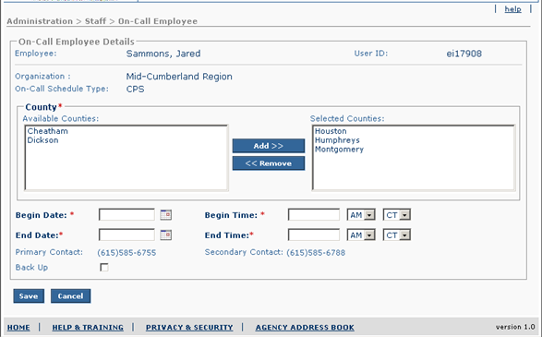
Figure 3 –On Call Detail Screen – Existing Screen Mock Up

To Be – Screen Mock Up
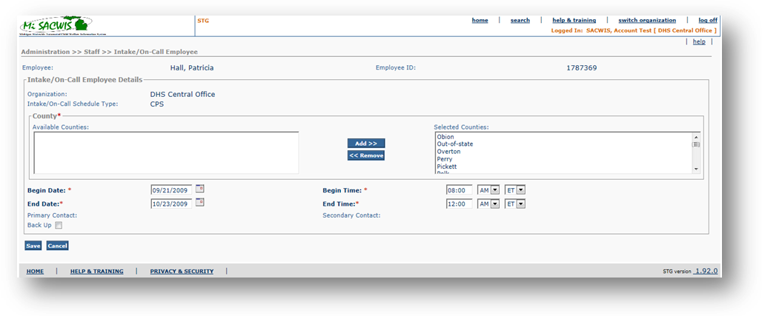

Figure 4 – Intake/On Call Detail – Updated Screen Mock Up

Screen Fields
Status (Keep/Add/Modify/Delete) | As Is  Class.Attribute Name | To Be  Class.Attribute Name | As Is  Display Name | To Be  Display Name | To Be  Type | To Be Align | To Be Size | To Be Read Only | To Be Calculation | To Be Edit Mask | To Be  UI Validation
Keep | Person.lastName + Person.firstName + Person.middleName | Person.lastName + + Person.suffixCode + Person.firstName + Person.middleName | Employee | Employee | Display text | L | 100 | T |  |  | Should be displayed with First, Middle and Last name
Modify | SecurityUser.InfoSecId | Employee.EmployeeId | User Id | Employee ID | Display text | L | 22 | T |  |  | Displays the unique identifier for an employee
Modify | N/A | N/A | On-Call Employee Details | Intake/On-Call Employee Details | Section Header | L | N/A | T
Keep | Agency.agencyName | Agency.agencyName | Organization | Organization | Display Text | L | 100 | T
Modify | OnCallStaff.scheduleType | OnCallStaff.scheduleType | On-Call Schedule Type: | Intake/On-Call Schedule Type: | Display Text | L | N/A | T |  |  | Carried forward from the selection made on the On-Call Employee Screen.
Keep | OnCallStaffCounty.GroupCode | OnCallStaffCounty.GroupCode | County | County | Mover Box | L | 30 | T | Domain Code=’County ‘ |  | Required field  List Derived from County Domain Code associated with selected Organization.
Keep | OnCallStaff.startDate | OnCallStaff.startDate | Begin Date | Begin Date | Date Field | L | 10 | F |  | MM/DD/YYYY | Required field
Keep | OnCallStaff.startDate | OnCallStaff.startDate | Begin Time | Begin Time | Date Field | L | N/A | F |  | Hh:mm | Required field
Keep | OnCallStaff.startDate | OnCallStaff.startDate | (Time Period) | (Time Period) | Drop Down Field | L | N/A | F | Domain Code='TimePeriod' | AM/PM
Keep | OnCallStaff.startDate | OnCallStaff.startDate | (Time Zone) | (Time Zone) | Drop Down Field | L | N/A | F | Domain Code = ’TimeZone' | ET/CT
Keep | OnCallStaff.endDate | OnCallStaff.endDate | End Date | End Date | Date Field | L | 10 | F |  | MM/DD/YYYY
Keep | OnCallStaff.endDate | OnCallStaff.endDate | End Time | End Time | Date Field | L | 10 | F |  | Hh:mm | Required field
Keep | OnCallStaff.endDate | OnCallStaff.endDate | (Time Period) | (Time Period) | Drop Down Field | L | N/A | F | Domain Code='TimePeriod' | AM/PM
Keep | OnCallStaff.endDate | OnCallStaff.endDate | (Time Zone) | (Time Zone) | Drop Down Field | L | N/A | F | Domain Code = ’TimeZone' | ET/CT
Keep | PartyContactMedium.partyContact | PartyContactMedium.partyContact | Primary Contact | Primary Contact | Display text | L | 130 | T |  |  | Derived from the contact record for the selected employee where Contact Type = ‘Primary On-Call Contact’ and the Primary flag is set to true.
Keep | PartyContactMedium.partyContact | PartyContactMedium.partyContact | Secondary Contact | Secondary Contact | Display Text | L | 130 | T |  |  | Derived from the contact record for the selected employee where Contact Type = ‘Secondary On-Call Contact’ and the Primary flag is set to true.
Keep | OnCallStaff.isBackupFlag | OnCallStaff.isBackupFlag | Back Up | Back Up | Check Box | L | N/A | F |  |  | Indicates if the employee will be a backup intake/on-call employee.

Action Buttons/Hyperlinks
Status (Keep/Add/Modify/Delete) | Label | Type | On Click Action/Navigation
Keep | Save | Button | Saves addition/modification on On-call detail page
Keep | Cancel | Button | Return to on-call employee page

Business Rules
No. | Status (Keep/Add/Modify/Delete) | Business Rule Description | Modified Business Rule Description | Execution Event (field tab out/save etc) | Error Msg Code  To be completed by Development Team
1 | Keep | The End Date/Time can never be before the Begin Date/Time. |  | Save Button;

Screen Navigation
No. | Status (Keep/Add/Modify/Delete) | To Screen Navigation Path
1 | Keep | This screen is presented after a selection is made from CF16 – Find an Employee in the Add scenario.
2 | Keep | This screen is accessed by clicking on the ‘select’ hyperlink on the On-call Employee Screen.

Pre-Conditions
No. | Status (Keep/Add/Modify/Delete) | Pre-Condition
 | N/A | N/A

    - Reference Values
No. | Status (Keep/Add/Modify/Delete) | To Be Class Attribute | Domain Code | Short Desc | Ref Data Code
1 | Keep | OnCallStaff.startDate &  OnCallStaff.endDate | TimePeriod | AM | AM
 |  |  |  | PM | PM
2 | Keep | OnCallStaff.startDate &  OnCallStaff.endDate | TimeZone | CT | CT
 |  |  |  | ET | ET
3 | Modify | AgencyCounty.countyCode | County | Non-Spec. County | NONSPECCOUNTY
 |  |  |  | Alcona | ALCONA
 |  |  |  | Alger | ALGER
 |  |  |  | Allegan | ALLEGAN
 |  |  |  | Alpena | ALPENA
 |  |  |  | Antrim | ANTRIM
 |  |  |  | Arenac | ARENAC
 |  |  |  | Baraga | BARAGA
 |  |  |  | Barry | BARRY
 |  |  |  | Bay | BAY
 |  |  |  | Benzie | BENZIE
 |  |  |  | Berrien | BERRIEN
 |  |  |  | Branch | BRANCH
 |  |  |  | Calhoun | CALHOUN
 |  |  |  | Cass | CASS
 |  |  |  | Charlevoix | CHARLEVOIX
 |  |  |  | Cheboygan | CHEBOYGAN
 |  |  |  | Chippewa | CHIPPEWA
 |  |  |  | Clare | CLARE
 |  |  |  | Clinton | CLINTON
 |  |  |  | Crawford | CRAWFORD
 |  |  |  | Delta | DELTA
 |  |  |  | Dickinson | DICKINSON
 |  |  |  | Eaton | EATON
 |  |  |  | Emmet | EMMET
 |  |  |  | Genesee | GENESEE
 |  |  |  | Gladwin | GLADWIN
 |  |  |  | Gogebic | GOGEBIC
 |  |  |  | Grand Traverse | GRANDTRAVERSE
 |  |  |  | Gratiot | GRATIOT
 |  |  |  | Hillsdale | HILLSDALE
 |  |  |  | Houghton | HOUGHTON
 |  |  |  | Huron | HURON
 |  |  |  | Ingham | INGHAM
 |  |  |  | Ionia | IONIA
 |  |  |  | Iosco | IOSCO
 |  |  |  | Iron | IRON
 |  |  |  | Isabella | ISABELLA
 |  |  |  | Jackson | JACKSON
 |  |  |  | Kalamazoo | KALAMAZOO
 |  |  |  | Kalkaska | KALKASKA
 |  |  |  | Kent | KENT
 |  |  |  | Keweenaw | KEWEENAW
 |  |  |  | Lake | LAKE
 |  |  |  | Lapeer | LAPEER
 |  |  |  | Leelanau | LEELANAU
 |  |  |  | Lenawee | LENAWEE
 |  |  |  | Livingston | LIVINGSTON
 |  |  |  | Luce | LUCE
 |  |  |  | Mackinac | MACKINAC
 |  |  |  | Macomb | MACOMB
 |  |  |  | Manistee | MANISTEE
 |  |  |  | Marquette | MARQUETTE
 |  |  |  | Mason | MASON
 |  |  |  | Mecosta | MECOSTA
 |  |  |  | Menominee | MENOMINEE
 |  |  |  | Midland | MIDLAND
 |  |  |  | Missaukee | MISSAUKEE
 |  |  |  | Monroe | MONROE
 |  |  |  | Montcalm | MONTCALM
 |  |  |  | Montmorency | MONTMORENCY
 |  |  |  | Muskegon | MUSKEGON
 |  |  |  | Newaygo | NEWAYGO
 |  |  |  | Oakland | OAKLAND
 |  |  |  | Oceana | OCEANA
 |  |  |  | Ogemaw | OGEMAW
 |  |  |  | Ontonagon | ONTONAGON
 |  |  |  | Osceola | OSCEOLA
 |  |  |  | Oscoda | OSCODA
 |  |  |  | Otsego | OTSEGO
 |  |  |  | Ottawa | OTTAWA
 |  |  |  | Presque Isle | PRESQUEISLE
 |  |  |  | Roscommon | ROSCOMMON
 |  |  |  | Saginaw | SAGINAW
 |  |  |  | St Clair | STCLAIR
 |  |  |  | St Joseph | STJOSEPH
 |  |  |  | Sanilac | SANILAC
 |  |  |  | Schoolcraft | SCHOOLCRAFT
 |  |  |  | Shiawassee | SHIAWASSEE
 |  |  |  | Tuscola | TUSCOLA
 |  |  |  | Van Buren | VANBUREN
 |  |  |  | Washtenaw | WASHTENAW
 |  |  |  | Wayne | WAYNE
 |  |  |  | Wexford | WEXFORD

